Use case diagram

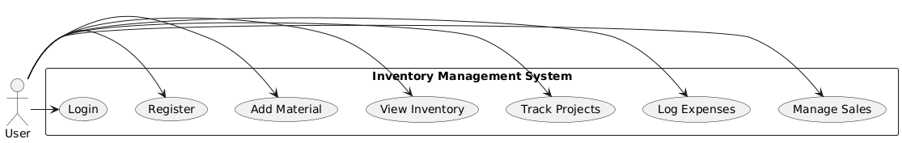

@startuml

actor User

rectangle "Inventory Management System" {

usecase "Login" as UC1

usecase "Register" as UC2

usecase "Add Material" as UC3

usecase "View Inventory" as UC4

usecase "Track Projects" as UC5

usecase "Log Expenses" as UC6

usecase "Manage Sales" as UC7

}

User -> UC1

User -> UC2

User -> UC3

User -> UC4

User -> UC5

User -> UC6

User -> UC7

@enduml